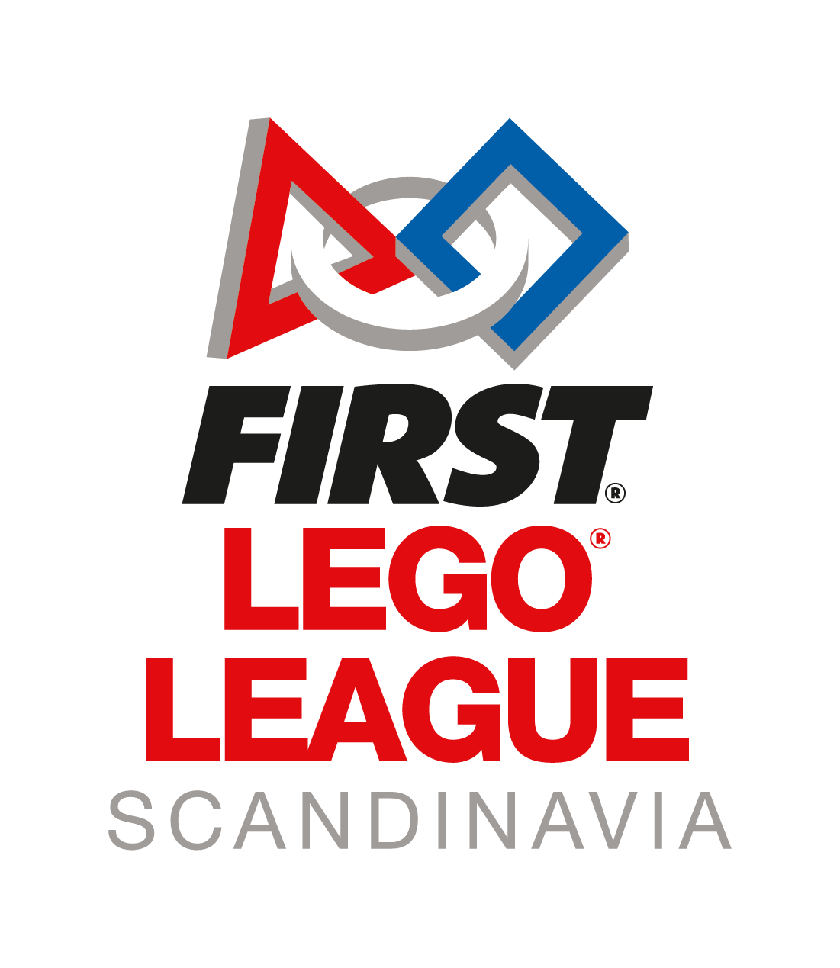
Report template

The head coach is responsible for uploading the team report.
The report should be uploaded as one (1) PDF in the provided google forms by May 1st.
The file can’t be more then 1 GB. Remember to compress the images before adding them to your file.

Character limit:
Project: 1000 words
Technology: 1000 words
Core values: 500 words
Image limit: max. five images per category (please compress images before uploading)

Innovative project
Problem statement:
What is the challenge you need to solve?
Results of research:
What information did you find about your problem statement?
Design process:
What processes did you use to design a solution to your problem?
Final solution:
What did you choose as the solution you will present?
Limitations:
What are the limitations of your solution?
Sharing:
Who have you shared your solution with? Have you shared your solution with anyone who could benefit from it?
Sources:
This can include printouts, digital resources and information from experts.

Technology
Robotic features:
What is your favorite?
What is most innovative?
Tools:
Describe your tools and their purpose.
Motors:
What motors does the robot have?
What is their purpose?
Sensors:
What sensors does the robot have and what is their purpose?
Strategy:
Briefly describe your strategy on the robot path.
Programming:
How many programs do you have?
Which program are you most satisfied with? Why?

Core values
Describe how you have worked with the different Core Values:
Discovery
Innovation
Impact
Inclusion
Teamwork
Fun

Reflect on your own efforts and comment on what has been good and what could have been done better/differently.

Do you have any questions? Please send these to our Head Judge, June.
June@firstscandinavia.org

